17MDC36 -BUSINESS STATISTICS LAB USING R   
  
  
MOVIE BOX OFFICE ANALYSIS

**TEAM MEMBERS:**

**-2033006 AVINASH R**

**-2033019 KISHORE KUMAR S**

**-203303 SHRIRAM R**

# **PROBLEM STATEMENT**

* POPULARITY OF MOVIES HAVE BEEN ON THE RISE NOWADAYS .
* SOME MOVIES GET GOOD RESULTS IN BOX OFFICE WHILE OTHERS DON’T.

# OBJECTIVE

TO ANALYSE THE GIVEN BOX OFFICE COLLECTION AND RATING OF DIFFERENT MOVIES DURING DIFFERENT YEARS USING VARIOUS ANALYSING AND VISUALISING TECHNIQUES IN R.

# DATA SET

2011 – 2021 DATA SET TAKEN FROM KAGGLE CONSISITING OF:

* Ratings
* Budget
* Box office collection
* Block(year)
* Order

[*https://www.kaggle.com/suneelpatel/movie-s-box-office-revenue-prediction/data*](https://www.kaggle.com/theoddwaffle/uber-data-analysis/data)

# TECHNIQUES USED

## 1)ONE WAY ANOVA:

**SOFTWARE USED: R STUDIO**

*IT WAS USED TO CHOOSE BASE WITH HIGHEST BOX OFFICE AND WITH YEAR OF RELEASE*

**CODE:**



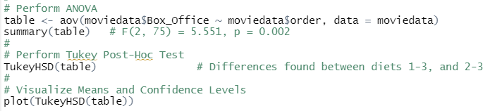

### ANALYSIS REPORTS AND INFERENCES:

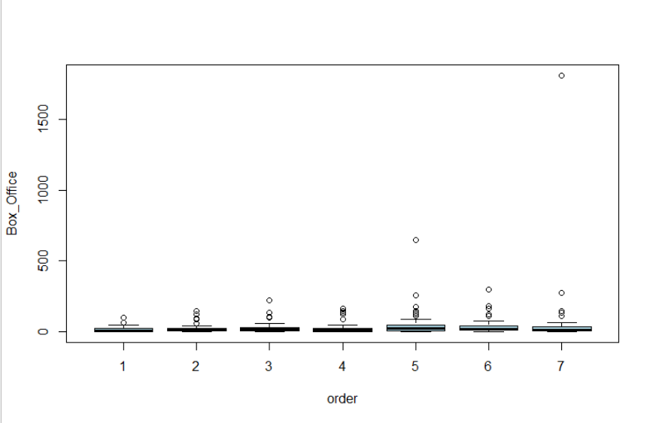

FROM THE GIVEN DATA,CALCULATING ANOVA,IT IS FOUND THAT THE THERE IS LESS VARIANCE IN BOX OFFICE WHEN COMPARING WITH THE YEARS.

## 2)LINEAR REGRESSION:

**SOFTWARE USED: R STUDIO**

*IT IS USED TO PREDICT BUDGET REQUIRED FOR GOOD BOX OFFICE COLLECTION*

**CODE:**

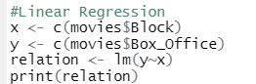



### SAMPLE OUTPUT:

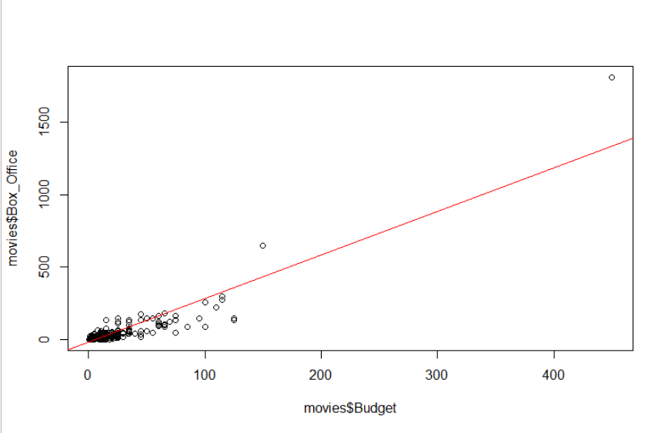

### INFERENCE:

*FROM THE SAMPLE OUTPUT ABOVE,IT IS FOUND THAT WE HAVE POSITIVE CORRELATION COEFFICIENTS FROM BOX OFFICE AND BUDGET .*

*SO, BUDGET HAG EHUGE EFFECT ON BOX OFFICE*

## 3)KRUSKAL-WALLIS AND CHI-SQUARED TEST:

**SOFTWARE USED:R STUDIO**

*TO EVALUATE THE STATISTICAL SIGNIFICANCE OF BOX OFFICE ,YEAR AND RATINGS.*

**CODE:**

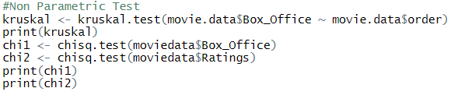

### ANALYSIS AND INFERENCE:

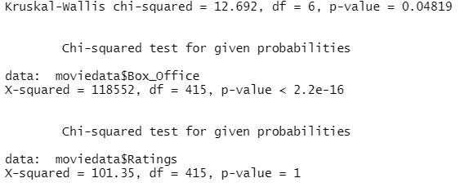

## 4) TIME SERIES FORECASTING:

**LIBRARY USED:FORECAST**

**SOFTWARE USED:R STUDIO**

*TO FORECAST THE BOX OFFICE FOR NEXT 10 YEARS.*

**CODE:**

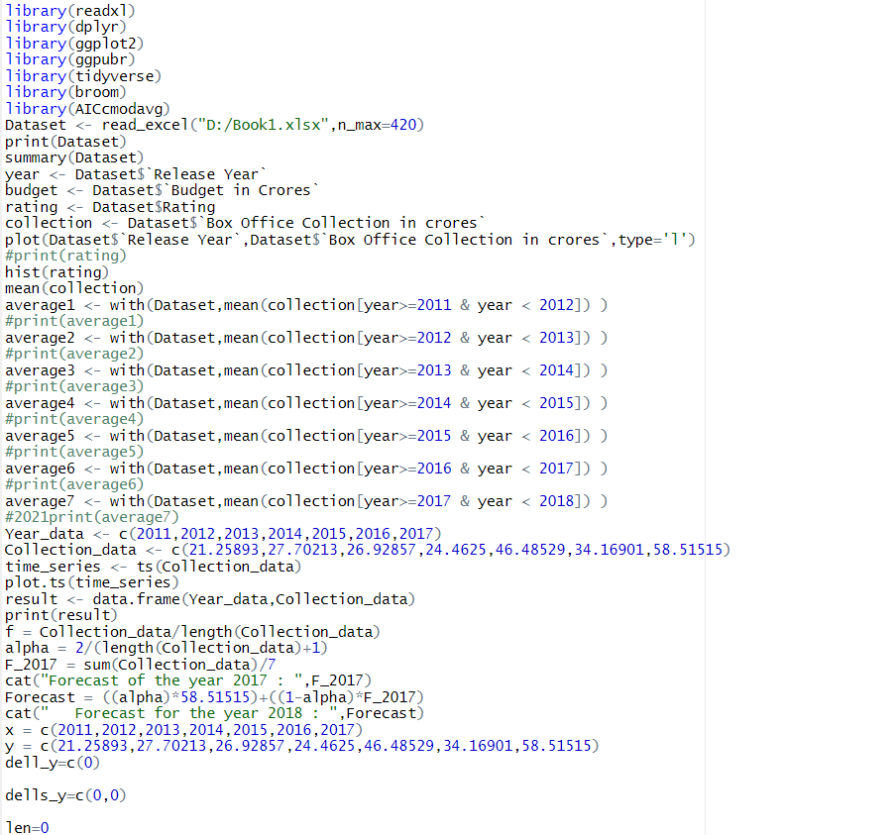

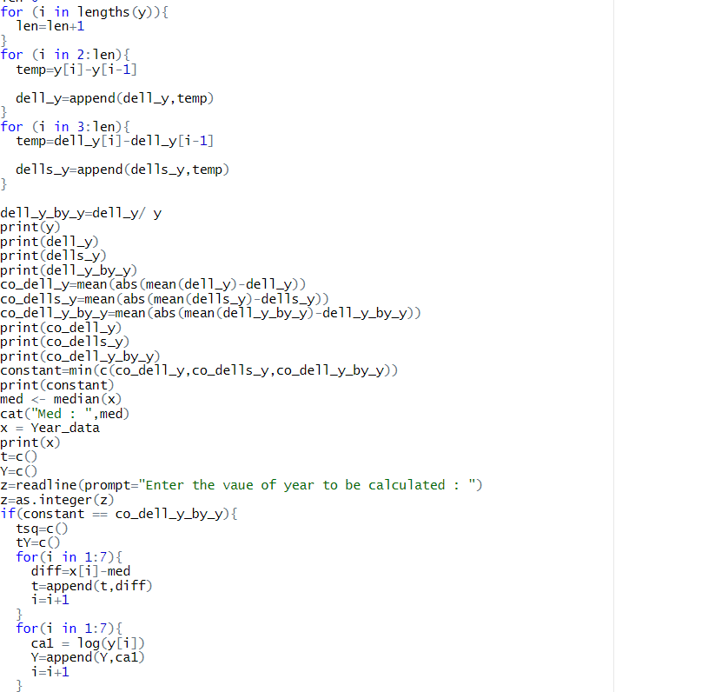

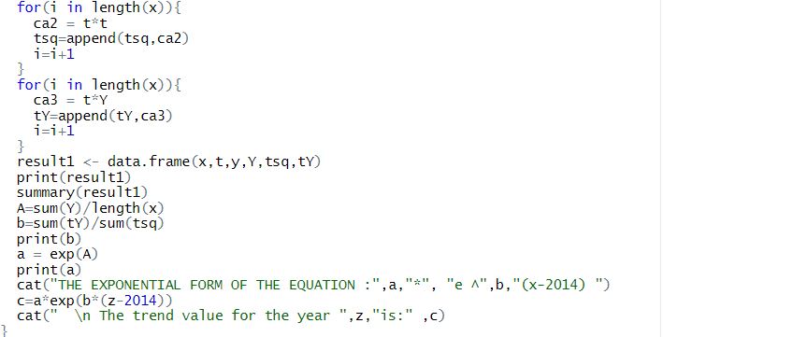

### ANALYSIS AND INFERENCE:

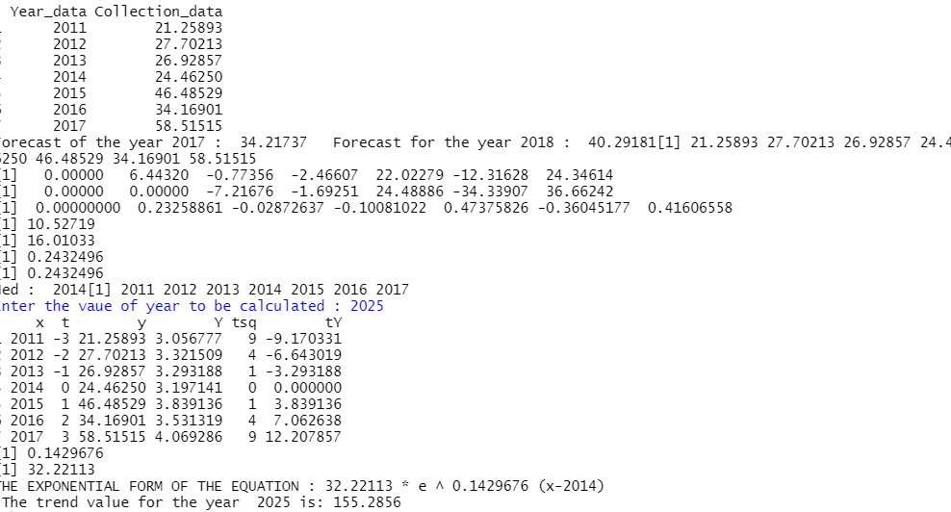

## 5)CORRELATION:

**LIBRARY USED:GGPLOT2**

**SOFTWARE USED: R STUDIO**

*TO STUDY THE RELATIONSHIP BETWEEN RATINGS AND BUDGET, BOX OFFICE AND BUDGET.*

**CODE:  
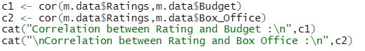**

### ANLAYSIS AND INFERECE:

### 

* *THIS MEANS THAT IF BUDGET IS INCREASED, RATING WILL ALSO INCREASE AND IF BUDGET IS LOW THEN RATING ALSO DECREASES.*
* *ALSO IF RATING IS INCREASED, BUDGET WILL ALSO INCREASE AND IF RATING IS LOW THEN BOX OFFICE ALSO DECREASES.*

# CONCLUSION

* *THROUGH THE FOLLOWING TESTS WE INFER THAT THE MOVIE’S BUDGET AND RATINGS PLAY A CRUCIAL ROLE IN IT’S BOX OFFICE COLLECTION.*
* *IF THE BUDGET AND RATINGS ARE HIGHER THE BOX OFFICE COLLECTION INCREASES.*
* *THE MOVIE BOX OFFICE TREND DOESN’T CHANGE WITH THE YEARS MUCH.*

**\*\*\*\*\*\*\*\*\*\*\*\*\*\*\*\*\*\*\*\***